A story about Air Quality in Europe:

**Author: Saravanan Natarajan**

**Tableau Story**: **Data Analyst Nanodegree**

**Visualization:** [Story Version 1](https://public.tableau.com/profile/saravanan.natarajan#!/vizhome/EuropeanPollutionProject_0/Story1), [Air Quality in Europe](https://public.tableau.com/profile/saravanan.natarajan#!/vizhome/EuropeanPollutionProject/AirQualityinEurope)

## Introduction:

Air pollution is a key environmental and social issue and, at the same time, it is a complex problem posing multiple challenges in terms of management and mitigation of harmful pollutants. Air pollutants are emitted from anthropogenic and natural sources; they may be either emitted directly (primary pollutants) or formed in the atmosphere (as secondary pollutants). They have a number of impacts on health, ecosystems, the built environment and the climate; they may be transported or formed over long distances; and they may affect large areas. Effective action to reduce the impacts of air pollution requires a good understanding of its causes, how they affect humans, ecosystems, the climate, and subsequently society and the economy. In this data analysis project, I have explored the European Environment Agency Air Quality Dataset and created European Pollution story using Tableau.

## Dataset:

[European Environment Agency Air Quality Dataset](https://www.eea.europa.eu/data-and-maps/data/aqereporting-8)

[Air Quality annual statistics calculated by the EEA](https://www.eea.europa.eu/data-and-maps/data/aqereporting-8)

[EEA data dictionary](http://dd.eionet.europa.eu/vocabulary/aq/pollutant)

## Summary:

The data collected from primary observation centres placed in countries in European Union were collected from the year 2011 to 2017.

Air pollution is the single largest environmental health risk in Europe and the disease burden resulting from air pollution is substantial (Lim et al., 2012; WHO, 2014). Heart disease and stroke are the most common reasons for premature death attributable to air pollution and are responsible for 80 % of cases; lung diseases and lung cancer follow (WHO, 2014). In addition to causing premature death, air pollution increases the incidence of a wide range of diseases

(e.g. respiratory and cardiovascular diseases and cancer), with both long- and short-term health effects, including at levels below the existing World Health Organization (WHO) guideline values. The International Agency for Research on Cancer has classified air pollution in general, as well as PM as a separate component of air pollution mixtures, as carcinogenic (IARC, 2013).

Indoor air pollution also poses considerable impacts on health (Lim et al., 2012; WHO, 2013a; RCP, 2016). In some situations, such as combustion of solid fuels in poorly ventilated chimneys and stoves, the sources of outdoor air pollution cause exposure and health impacts in addition to those from the indoor air pollution.

The primary focus of Tableau story is to explore the various air polluting substances and their levels in Europe from 2011 to 2017.

## Design:

In the Story Version 1 the countries with highest pollution recorded, various air polluting components and map based visualisation of air pollution was captured.

After discussing this story with various people, identified the reporting year was placed under Measures by the Tableau and the Data type was Number (Whole).

After converting the year to Dimensions and type as date gave lots of visualisation change.

Adding Pages for map gave pollutants measured in each country a play view and easy to explore.

The treemaps help to identify major pollutants recorded over the years.

The area chart (continuous) shows the variations among the major pollutants recorded over the year.

Filled map provided us the view of major pollutant over the year in each country, we can select each pollutant and the loop playback helped to view the value over each country.

## Feedback:

Hi Saravanan,

First I would like to congratulate you for this nice piece of work.

But I would also like to leave you a feedback for further refinement of this dashboard.

1. If you can bring all the sheets in a container the views will look much more sorted. Try using vertical or horizontal containers.

2. If you enable heading it will give user an idea what exactly they are looking at.

3. You can give tab’s a more meaningful name like: Pollution Over in Europe, Pollutants contributing to maximum pollution etc.

4. You also try reordering tab’s with last as first (because it shows overview) then others.

Rest everything looks good to me.

Best Regards,

Ravi Malhotra | GQR Data & Analytics Team

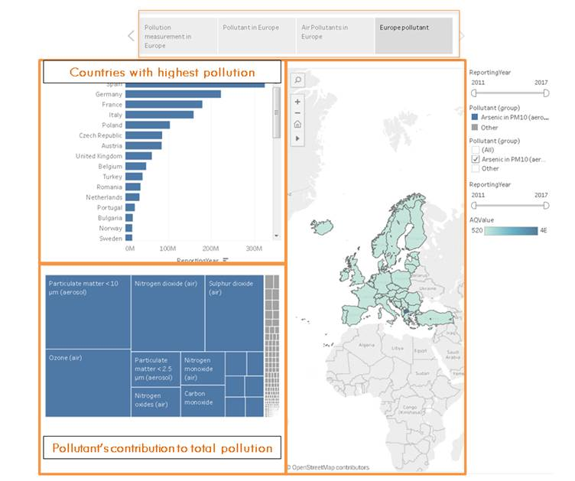

## Resources:

[Tableau Project](https://github.com/jubins/Tableau-Projects/blob/master/ProsperLoanData/Tableau_writeup_JubinSoni.pdf)

[Air Quality Report in Europe - 2017](https://www.eea.europa.eu/publications/air-quality-in-europe-2017)

[Air Pollution Europe](https://public.tableau.com/ja-jp/s/gallery/air-pollution-europe)

[Up-to-date air quality data](https://tableau.discomap.eea.europa.eu/t/Aironline/views/Up-to-dateairqualitydata/UpToDateAirQualityData?%3Aembed=y&%3AshowShareOptions=true&%3Adisplay_count=no&%3AshowVizHome=no)

[Details on methodology used by EEA to calculate air quality aggregations and statistics](http://www.eionet.europa.eu/aqportal/toolbox/guidance/doc/ETC_Aggregation_v0.8.2_final.pdf)